The Massachusetts

Prescription Monitoring Program

A Report to the Massachusetts General Court

February 2015





Governor

Charles D. Baker

Secretary of Health and Human Services

Marylou Sudders

Massachusetts Department of Public Health

Commissioner Monica Bharel, MD, MPH

***Prepared by***

The Bureau of Health Care Safety and Quality

Deborah Allwes, BS, BSN, RN, MPH, Director

The Office of Prescription Monitoring and Drug Control

Jonathan Mundy, R.Ph, MBA, Director

# Executive Summary

Section 37 of Chapter 258 of the Acts of 2014 directs the Department of Public Health’s (DPH) Drug Control Program (DCP) to submit a report to the Massachusetts General Court that includes information on the Prescription Monitoring Program’s (PMP) data and implementation to-date. This report highlights those key data elements, including that:

* 60% of doctors (MD and Doctor of Osteopathic Medicine or “DO”) are enrolled in the PMP, with an increase in enrollments following passage of mandatory of utilization by Chapter 244 of the Acts of 2012. Automatic enrollment of all prescribers occurs concurrently with the renewal of their Massachusetts Controlled Substance Registration (MCSR).
* 100% of Massachusetts licensed retail pharmacies submit data into the PMP, including prescription drugs dispensed from hospital outpatient pharmacies, clinic pharmacies, retail pharmacies, and out-of-state mail order pharmacies that deliver to patients in Massachusetts.
* Not all prescribers enrolled in the PMP prescribe controlled substances on a regular basis; for example, 42% of prescribers enrolled in the PMP issued <10 Schedule II-V prescriptions during 2014.
* Recent rates of *multiple provider episodes* (individuals who have received prescriptions from multiple providers) have declined; this trend could suggest that the use of the PMP since 2010 may have had a positive impact on statewide prescribing volumes.
* Each month, a thorough review of prescribing patterns, dispensing patterns and prescription drug product usage data by prescribers is conducted by DCP staff.
* From January 2013 to November 2014, there were 38 cases presented by DCP following review and analysis of standard criteria, of which 13 cases were released to the Massachusetts boards of registration in medicine, nursing, and physician assistants; 25 cases were found to be consistent with the practitioner’s area of practice or within the acceptable needs of appropriate medical care. No cases during this time period were referred by DCP to law enforcement.

Collecting and analyzing PMP data allows DCP to conduct epidemiological surveillance and provides useful information that supports a multitude of programs. Utilization of the PMP can assist providers in the identification of potential prescription drug misuse, abuse, and diversion, while helping to ensure that patients who need these medications have access to them.

DCP is conducting several major ongoing initiatives to improve the PMP, such as interstate data sharing (the ability of the PMP to query other state’s PMP systems); accessing the PMP from provider’s electronic health records (EHR); making the PMP easier for providers to access and use; and improvements to the information technology.

Through these improvements and with additional system enhancements and collaboration with the prescriber community, DCP expects to further expand PMP utilization and looks forward to collaborating with the legislature in its efforts to curb the prescription drug abuse epidemic in the Commonwealth.

# Purpose

Section 37 of Chapter 258 of the Acts of 2014 directs the Department of Public Health’s (DPH) Drug Control Program (DCP) to submit a report to the Massachusetts General Court that

“shall include, but not be limited to the following information: an analysis of whether practitioners are using the prescription monitoring program prior to prescribing drugs contained in schedule II; the number of violations of law or breaches of professional standards that were referred to law enforcement or a professional licensing, certification or regulatory agency or entity, under 105 CMR 700.012 (D) (5)(a), between January 1, 2013 and November 1, 2014; the type of violations of law or breaches of professional standards that were referred to an outside entity between January 1, 2013 and November 1, 2014; the outcome of the referrals; and recommendations about how to improve the use of the prescription monitoring program’s data to establish best practices for prescribing, to identify indicators of  risk for addiction and to prevent prescription drug abuse and the diversion of prescription drugs.”

The purpose of this report is to provide this mandated information, including an overview of DCP’s ongoing work regarding provider enrollment data collection in the Prescription Monitoring Program (PMP); innovative expansion of the PMP through interstate data sharing and electronic integration with provider electronic health records; expanding the role of delegates to access the PMP on behalf of a licensed prescriber, and ongoing engagement efforts with law enforcement personnel, among other outreach and expansion initiatives.

# A Note about the Data

Given the need for quality assurance and data integrity, the data for calendar year 2014 will be available at the end of March 2015. This report includes data until the end of 2013. This report will be updated upon final review and availability of the 2014 data.

More specifically, the availability of the 2014 data is contingent on reporting of the PMP data by pharmacies, including edits to previously reported data. Data for 2014 is updated throughout January and early February. This data is then checked for accuracy and consistency, after which data analysis can begin.

For example, the pharmacy reports the prescription as “dispensed” once the prescription is filled. However, if the prescription is not picked up by the patient, or the prescriber cancels the prescription and orders a new one in its place, a slight delay in the collection and synthesis of the data prevents the PMP from incorrectly showing that a prescription was dispensed, when, in fact, it was not received by the patient.

# The Massachusetts Prescription Monitoring Program

In Massachusetts, prescription drugs are classified in Schedules I through VI, with schedules I – V matching the federal Drug Enforcement Administration (DEA) designations of controlled substances, defined in Massachusetts as a drug, substance, or immediate precursor in any schedule or class referred to in chapter 94C of the General Laws. Schedule I drugs (e.g. heroin) have no accepted medical use, and therefore, cannot be prescribed. Schedule VI drugs are not controlled by the DEA, but are in a category created at the state level, as is the case in Massachusetts, and still require a prescription in order to dispense. These Schedule VI prescription drugs include EpiPens, antibiotics, and other routine and lower-risk medications. Schedule II drugs have the highest potential of prescribed drugs for abuse, while Schedule V represent the lowest. The Department of Public Health’s (DPH) Massachusetts Prescription Monitoring Program (PMP) monitors all prescription drug products in Schedules II – V.

The PMP serves as a repository of data for all Schedule II – V prescription drugs dispensed statewide, including prescription drugs dispensed from hospital outpatient pharmacies, clinic pharmacies, retail pharmacies and out-of-state, mail order pharmacies that deliver to patients in Massachusetts. Pharmacies must submit the prescription drug data to the PMP at least once every seven days and no late then ten days after dispensing, as required in Massachusetts regulation 105 CMR 700.012. While the PMP data is not considered available in real-time (up to the minute), the prescription information in the PMP is current within 10 days of being dispensed. An initiative is currently underway by the PMP staff to promote reporting of dispensed prescription medications within 24 hours.

The PMP also enables enrolled prescribers and dispensers to access a patient’s Schedule II – V prescription drug history. As is consistent with other national standards and state PMPs, the PMP serves as a repository of all Schedule II – V the prescription medications a patient has been prescribed and dispensed in the past 12 months, allowing the provider to have a holistic view of the patient’s medications.

Prescription histories can be used as a clinical decision-making tool. Patients with multiple and complex conditions often require many health care providers. The collection of this patient prescription drug information (see Figure 1) allows DCP, through its oversight of the PMP, to conduct epidemiological surveillance and provide useful information in support of a multitude of programs within DPH, as well as law enforcement and community-based drug prevention programs. To that end, the PMP is recognized as an important resource in the fight against prescription drug abuse. In fact, to help combat the prescription drug abuse epidemic, the Centers for Disease Control and Prevention (CDC) recommended in 2011 that states establish prescription drug monitoring programs (PDMPs) like the PMP established in Massachusetts. [1]

In 1992, the PMP was established through joint regulations from the Massachusetts Drug Control Program (DCP) within the Massachusetts Department of Public Health’s Bureau of Health Care Safety and Quality (BHCSQ), and the Board of Registration in Pharmacy. In 2010, as a result of state appropriations and grants from the Bureau of Justice Assistance (BJA), the DCP launched an online version of the PMP. The PMP database contains all prescription data from 1992 forward.

Prior to 2012, enrollment in this program remained voluntary for prescribers. However, Chapter 244 of the Acts of 2012 made enrollment in the PMP a requirement for physicians, dentists and podiatrists. Additional statutory language was added in August 2013 mandating enrollment of all prescribers, including Advance Practice Registered Nurses (APRN) and Physician Assistants (PA). Following enactment of these requirements, the Public Health Council (PHC) passed regulations requiring the automatic enrollment of APRNs and PAs in November 2014.

Figure 1: Collection of Data through the PMP



As of December 2014, 27,730 prescribers and dispensers enrolled in the PMP. This number does not include law enforcement officials (for the purpose of active, open and drug related investigations) thathave been enrolled to use the system. All prescribers are expected to be enrolled by the fall of 2015. Automatic enrollment of all prescribers happens concurrently with the renewal of their Massachusetts Controlled Substance Registration (MCSR), the registration that grants them the authority to prescribe in Massachusetts (see Table 1). Efforts continue to expand enrollment in the PMP by encouraging pharmacists and others to enroll. In August 2013, Section 24A of Chapter 94C of the General Laws was amended to allow prescribers and dispensers enrolled in the PMP to have authorized support staff (known as “delegates”) enroll in the PMP, which will help enrollees utilize *batch lookup* and other improvements discussed later in this report. DCP will begin enrolling these delegates in 2015.

Table 1: Enrollment of Providers in the PMP through December 2014

|  |  |  |  |  |  |
| --- | --- | --- | --- | --- | --- |
| **Enrollment Of Providers In The MA Online PMP Through December 2014** | | | | | |
|  | **Voluntary Enrollment**  Dec 1, 2010 -  Dec 31, 2012 | **Voluntary and**  **Automatic Enrollment\***  Jan 1, 2013- Dec  2014 | **Total Enrolled**  (As of Dec 2014) | **Estimated Number practicing in MA** | **Total Percentage Enrolled**  (of  Eligible Providers) |
| **Practitioners**  **(MD / DO)** | 2,657 | 19,783 | 22,440 | 34,173 | **66%** |
| **Mid-Levels**  **(APRN / PA)** | 850 | 1,186 | 2,036 | 8,626 | **24%** |
| **Pharmacists** | 477 | 2,777 | 3,254 | 12,000 | **27%** |
| **Total Enrollment1** | **3,984** | **23,746** | **27,730** | **54,799** | **51%** |
| **1 Total enrollment only includes providers; excludes law enforcement and regulatory agency enrollment**  **\* Automatic enrollment applies to practitioners; Mid-level prescribers started automatic enrollment in January 2015 and pharmacist Online PMP enrollment continues to be voluntary** | | | | | |

Utilization of the PMP can assist in identifying potential prescription drug misuse, abuse, and diversion, while helping to ensure that patients who need these medications have access to them. A key feature of the PMP is the electronic notification of providers who are reported to have prescribed controlled substances to individuals who have received prescriptions from multiple providers; referred to as “multiple provider episodes” (MPE). Creating these alerts was a priority during the development phase of the PMP.

The PMP database contains all prescription data from 1992 forward. Analysis of this data demonstrates that MPEs increased by 256 percent between FY 1996 and FY 2008. In calendar year 2001, more than 17,600 individuals showed possible MPE activity for Schedule II – V prescription drugs. Recently however, rates of MPEs have declined, dropping from 1,687 per 100,000 persons in calendar year 2009 to 1,450 per 100,000 persons in calendar year 2013 - a 15 percent decline (see Figure 2). This trend may suggest that the use of the PMP since 2010 may have had a positive impact on prescribing volume.

Figure 2: Multiple Provider Episode Trends Over Time

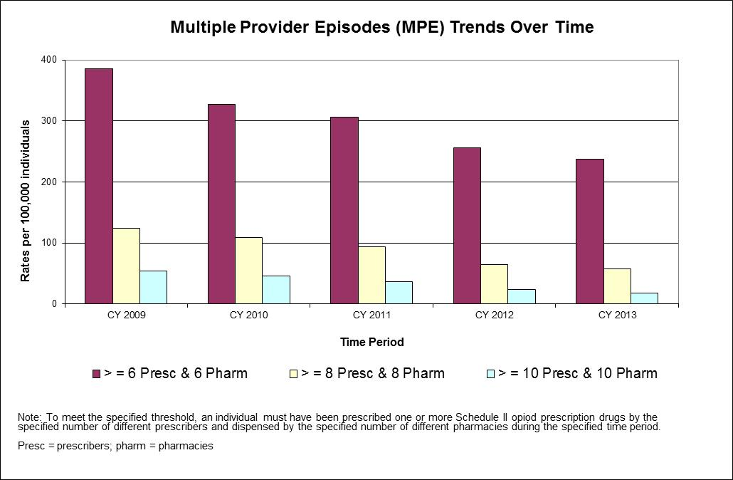

Figure 3: Impact of MPE Electronic Alert Notifications

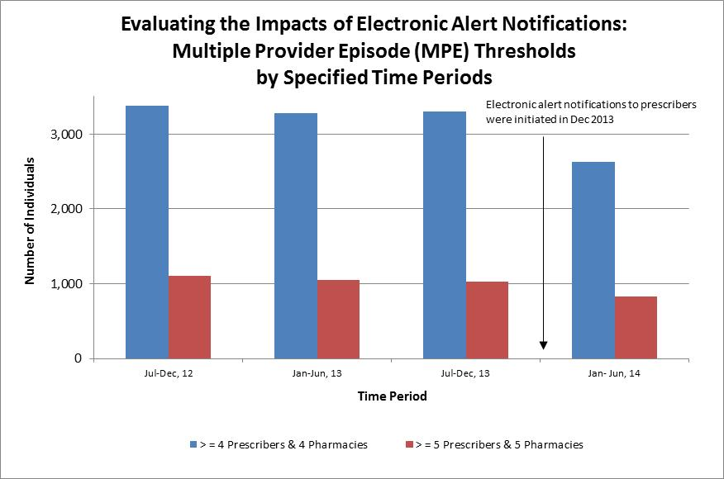

Also noteworthy is that some prescribers who received the initial alerts did not have patients who met the alert threshold in succeeding months. This suggests that viewing the PMP data may have influenced their prescribing behavior. While the general feedback from prescribers regarding the electronic alerts was very positive, there continues to be ongoing concerns about the time necessary to access the PMP and work flow issues.

Among the most significant findings is that most prescribers (85%) felt more confident about prescribing controlled substances after viewing the PMP. It is also noteworthy that following initiation of alerts, the number of individuals with multiple provider episodes (MPE), at two specified MPE levels, declined (see Figure 3).

To this end, the PMP staffs have begun the process to identify PMP systems used in other states that contain the functionality and ease-of-use needed to have successful utilization of the PMP. Planned improvements are already underway. The PMP is currently under a pilot program to interface with electronic health records (EHR) from a pharmacy, an emergency department and a large private practice facility. The ability of the EHR to query the PMP will lessen the time it takes to look up a patient’s PMP information and will allow providers to seamlessly have all the information they need to provide the best possible care for the patient.

# Are Practitioners Using the Prescription Monitoring Program?

Chapter 258 of the Acts of 2014 requires “an analysis of whether practitioners are using the prescription monitoring program prior to prescribing drugs contained in Schedule II”. Practitioners include both prescribers and dispensers. [2] Practitioners may also use the PMP through delegates.[3]

The PMP provides authorized users (prescribers, dispensers, law enforcement engaged in an open investigation, and prescriber licensing boards) with the ability to query a web-based system to obtain patients’ controlled substances prescription histories. Additionally, the PMP can be used to screen for, and identify, individuals who may be prescribed multiple drugs. Providing this data online has improved prescriber and pharmacist access to necessary patient information and allows timely interventions with at-risk patients, improving medical care and containing costs.

To that end, DCP is currently engaged in information technology improvements to the PMP system to allow for greater responsiveness and capacity to electronically report practitioners’ use of the PMP prior to prescribing. These modifications are expected to take place throughout 2015.

DCP conducted an analysis to determine the utilization of the PMP by enrolled prescribers prior to issuing a prescription for a Schedule II controlled substance drug product. The PMP prescription data were analyzed for a four-month time period (August 1 through November 30, 2014). The criteria used to determine a patient query by a prescriber was based on whether the enrolled prescriber logged on to the system and conducted a search between July 1, 2014 (as noted in the PMP audit records) and the date the prescription was written (as reported by the dispensing pharmacy).

Utilization of the PMP by prescribers depends on many factors (e.g., provider specialty, frequency of prescribing controlled substances, ready access to and comfort level with information technology). Not all prescribers enrolled in the PMP prescribe controlled substances on a regular basis or at all. For example, fewer than two-thirds (58 percent) of prescribers enrolled in the PMP issued more than 10 Schedule II-V prescriptions during 2014. This percentage goes down further when just considering Schedule II narcotic and/or Schedule IV benzodiazepine prescriptions.

Approximately 25 percent of enrolled prescribers have logged in to the PMP at least once in the past year. Over fifty percent of enrolled prescribers have never logged in to the system, in part because some enrolled prescribers do not prescribe Schedule II-V controlled substances.

An analysis in calendar year 2011, showed that the prescribers in the top three deciles, who account for nearly 90 percent of all the Schedule II-V prescriptions issued and dispensed in Massachusetts, were enrolled in the PMP at considerably higher percentages compared to prescribers in the bottom seven deciles.

Automatic enrollment of prescribers who do not prescribe Schedule II-V controlled substances may account for some of this change. Any interpretation of PMP utilization by enrollees must consider that, because the automatic enrollment process includes a significant proportion of prescribers who would not routinely use the PMP, the number of providers that utilize the PMP will be different than the enrolled providers (e.g., prescribers who possess an MCSR but are primarily educators, researchers or practice in specialties such as pathology).

Recent analyses on PMP Schedule II prescription opioid data demonstrate that nearly 90 percent of these prescriptions were issued by only 30 percent of the total of authorized prescribers with an MCSR. This is consistent with the prescribing patterns for controlled substance drug products that have been reported by the Centers for Disease Control and Prevention (CDC) (Presentation by Dr. Len Paulozzi for the 2013 Harold Rogers Bureau of Justice Assistance National Meeting) for other states.

Between August 1 and November 30, a total of 16,997 prescriptions for Schedule II drug products were considered to have been looked up by prescribers enrolled in the PMP. These 16,997 prescriptions were associated with 926 different prescribers who conducted a patient query during this time period. There is no reliable methodology for calculating the denominator (i.e., the total number of individual prescribers who looked up a patient upon considering prescribing a Schedule II controlled substance) because of current limitations of the query reports that the program is able to generate. Information technology upgrades, in progress as discussed above, may help to alleviate these limitations.

Figure 4: Number of Schedule II Prescriptions Reported to PMP between 1992 and 2013

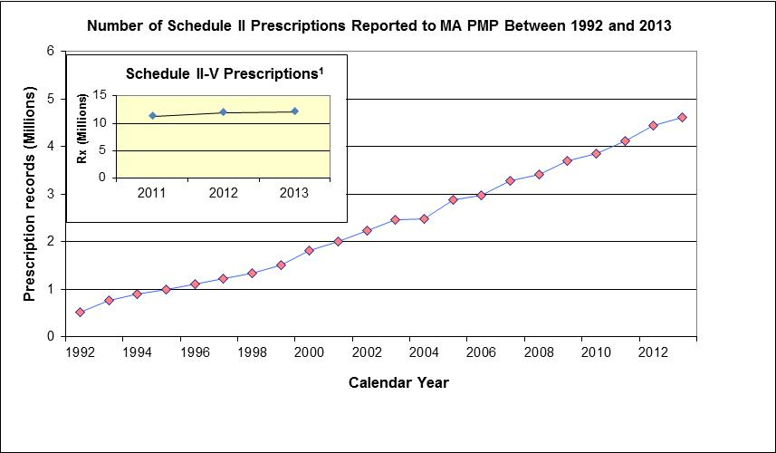

1 PMP began requiring pharmacies to report Schedules III-V prescriptions in Jan, 2011

However, based on the number of prescribers who looked up a patient during this time period (n = 926) and the estimated number of enrolled prescribers (n = 13,865) who wrote at least one Schedule II prescription specified during the time period, it is estimated that about seven percent of prescribers are looking up patients prior to writing a Schedule II prescription. While this percentage of prescribers is low, DCP recognizes, as stated above, that not all prescribers enrolled in the PMP prescribe controlled substances on a regular basis. DCP is working to identify the total number of providers who should be using the PMP so that targeted outreach and monitoring efforts can be implemented.

**Figure 5: Schedule II-V Prescriptions Reported to the PMP by Drug Category in Calendar Year 2013**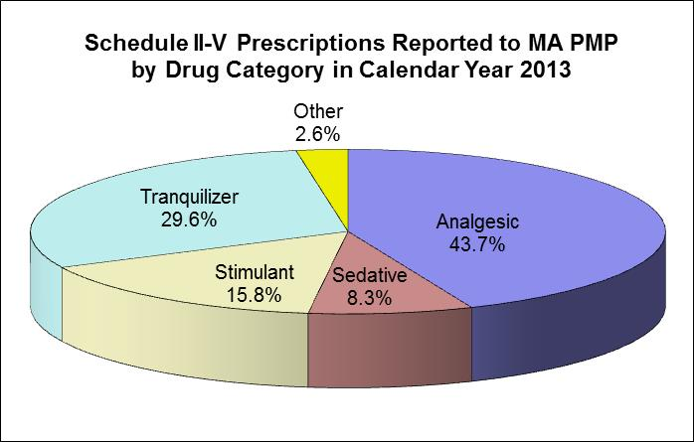

As of September 2014, 22,863 prescribers and 3,053 pharmacists are enrolled in the PMP. DCP recorded 751 electronic alert notifications in FY14. During calendar year 2013, 12,049,808 Schedule II-V prescriptions were reported to the PMP. Forty-eight percent (5,833,557) of these were Schedule II controlled substance drug products. (See Table 2 below).

Table 2: Schedule II-V Prescriptions Reported to the PMP

| Schedule II-V Prescriptions Reported to the PMP | | |
| --- | --- | --- |
| Month (CY2013) | **Schedule II-V** | **Schedule II Only** |
| January | 1,077,359 | 512,141 |
| February | 930,873 | 449,938 |
| March | 1,010,822 | 492,828 |
| April | 1,013,707 | 490,219 |
| May | 1,042,113 | 511,891 |
| June | 960,638 | 468,633 |
| July | 1,005,472 | 482,541 |
| August | 999,137 | 486,196 |
| September | 967,403 | 469,116 |
| October | 1,050,061 | 509,861 |
| November | 968,913 | 470,665 |
| December | 1,023,310 | 489,528 |
| Total CY 2013 | 12,049,808 | 5,833,557 |

# Prescription Monitoring Program Violations and Breaches

Chapter 258 of the Acts of 2014 further requires DCP to report “the number of violations of law or breaches of professional standards that were referred to law enforcement or a professional licensing, certification or regulatory agency or entity, under 105 CMR 700.012 (D) (5)(a), between January 1, 2013 and November 1, 2014; the type of violations of law or breaches of professional standards that were referred to an outside entity between January 1, 2013 and November 1, 2014; the outcome of the referrals”.

The PMP Medical Review Group (MRG), was established under 105 CMR 700.012(C) by the Commissioner of DPH to advise DCP in the evaluation of prescription information and clinical aspects of the implementation of the PMP. The MRG consists of prescribers and dispensers who review information on prescribing patterns, dispensing patterns and prescription drug product usage data. Individually, the current members have extensive clinical backgrounds in dentistry, medicine and pharmacy. Their combined experience on the MRG makes this an expert group on prescription drug prescribing and dispensing in Massachusetts.

DCP does not draw conclusions about the legality or legitimacy of the activities of a prescriber, pharmacy or patient based on PMP data. The PMP is never the only source of information used in conducting a regulatory or law enforcement agency investigation as there are many factors that need to be taken into account when determining if a referral to an agency or board is warranted.

DCP presents the MRG with cases for review after a thorough analysis of total PMP data results, based on standardized criteria. In reviewing these cases, the MRG is able to advise DCP and may recommend that cases be referred to the appropriate board of registration or federal regulatory authority. The MRG may also recommend that additional information be provided at a subsequent monthly meeting.

PMP staff present case information to the MRG on prescribers and dispensers. Prescribers and dispensers are also identified for review by the MRG based on the prescription data relative to other similar practitioners. For example, the prescription data for an orthopedic surgeon is compared to another orthopedic surgeon and, if possible, within the same approximate geographic area.

The MRG case data and information includes:

* Prescriber time-period comparisons for total prescriptions prescribed and individual drug products;
* Prescription data for two time periods that are compared - a previous time period (e.g., January 1 through March 31) compared to a current time period (e.g., June 1 through August 31).

The prescription data included in the comparison are:

* Total Number Prescriptions - Numerical and percentage change
* Total Quantity/Doses - Numerical and percentage change
* Average Quantity per Prescription - Numerical and percentage change
* Average Quantity per individual drug product (usually as generic drug product)
* A report with twelve month totals (if available) for all prescriptions and individual drug products

The prescription data are mapped according to the zip code of dispensing pharmacy and/or of the patient. A summary of prescriptions with totals for each drug product, total number of unique patients who were dispensed that drug product, and either the total number of prescribers or pharmacies per drug product are analyzed.

A spreadsheet of a sample time period for de-identified patients with columns for drug, quantity, number of days of supply, date prescription written, date prescription dispensed, prescriber, prescriber city, pharmacy, pharmacy city, is most commonly sorted on the date the prescription is written. Other fields that may be included in the spreadsheet are method of payment, customer and relationship of customer to patient.

Other information that may be included for the MRG to consider is information on the individual from specific boards of registration websites (e.g. The Board of Registration in Medicine includes specialty, board certifications, date license issued, practice address etc.); the rank among similar prescribers, represented as a number or presented graphically in a chart; or drug products that are reported to be desirable for misuse and abuse.

The MRG’s recommendations are based on comparative analysis of prescription data and other information. Based on experience and knowledge, the MRG and PMP staff may identify data trends for prescribers or dispensers that are outliers. The MRG will consider the available data and information and may recommend that the prescriber’s or dispenser’s data be brought to the attention of the appropriate authority as a referral.

**Number of violations and breaches**

* From January 2013 to November 2014, the MRG reviewed 38 cases presented by DCP following review and analysis of standard criteria.
* 13 cases were released to the Massachusetts boards of registration in medicine, nursing, and physician assistants, pursuant to MRG recommendation.
* 25 cases were found to be consistent with the practitioner’s area of practice or within the acceptable needs of appropriate medical care.
* 0 cases were referred by DCP to law enforcement.

**Types of violations and breaches**

* Once referrals are made, law enforcement and the Boards conduct their own investigation into the cases presented to them.
* In order to maintain a separation between data collection and regulatory enforcement, DCP does not receive information on the specific cases referred, and therefore, is unable to report on the type of violation or breach that led to, or was discovered by, the investigation.

**Outcome of violations and breaches**

* Given that investigations by Boards and law enforcement are not shared with DCP, the only outcome DCP may be informed of is whether there is a need for a prescriber to surrender their MCSR, the process for which is outlined below.
* Of the 38 cases reviewed by the MRG, 0 cases resulted in a recommendation to surrender an MCSR.

## Surrender of Massachusetts Controlled Substances Registration

The Drug Control Program is responsible for issuing, to persons duly authorized to practice their profession, an MCSR that permits dispensing of controlled substances by a prescription. DCP is also responsible for automatically enrolling a person who is obtaining or renewing an MCSR as a participant in the PMP.

Upon receipt of notification that a board of registration has suspended or revoked a registrant’s authorization to practice, DCP may terminate the permission to dispense, including co-incidental activities and enrollment in the PMP, by sending a letter by registered mail informing the practitioner of the intention to terminate their MCSR, requesting the return of the MCSR certificate (or a Statement of Constructive Surrender) to DCP, and making notations in DCP, MCSR and PMP databases.

# Recommendations to Increase Usage of the Prescription Monitoring Program

Chapter 258 of the Acts of 2014 further mandates “recommendations about how to improve the use of the prescription monitoring program’s data to establish best practices for prescribing, to identify indicators of  risk for addiction and to prevent prescription drug abuse and the diversion of prescription drugs”. The information below outlines the recommendations, current efforts and planned modifications to the PMP.

Moving forward, two significant challenges face DCP: developing more robust analyses to help assess the magnitude of the prescription drug epidemic at the community level; and successfully finalizing memorandums of understanding (MOUs) with other states to allow for the implementation of interstate data sharing.

**Best Practices for Prescribing**

A recognized best practice of prescription monitoring programs by the PMP Center of Excellence is interstate data sharing, which DCP recommends as part of continuing enhancements to the PMP. Interstate data sharing is when PMP data is exchanged between authorized users in Massachusetts and those from a cooperating state. A set of consensus-based national standards, known as Prescription Monitoring Information Exchange (PMIX) specifications, has already been created to enable states’ PMPs to share data. Massachusetts has selected RxCheck as its operational interstate data sharing hub that implements the PMIX specifications and provides for the interstate exchange of data.



Source: Alliance of States with PMPs. April 2012

DCP has initiated operations for admission into the RxCheck Hub, including developing work specifications for Information Technology (IT) vendors, hiring a PMIX IT project manager and drafting a variety of Memoranda of Understanding (MOU) to establish formal data sharing agreements with other state PMPs. Draft MOUs have been developed for Kentucky, Maine and Connecticut and are currently under review.

IT coding and preliminary implementation of the system is being done in stages, with stage I allowing data to be sent in response to a request by a cooperating state anticipated to be complete by end of year 2014. Stage 2, which will allow Massachusetts’ providers to initiate a request to a cooperating state, is anticipated to begin immediately after Stage 1. Following implementation of the system, DCP will begin pilot testing PMP data requests by Massachusetts for Kentucky, Maine and Connecticut PMP data and reciprocal requests for PMP data. DCP recommends an increased focus on prioritizing interstate MOUs with New England states.

**Improvements for Health Care Providers**

DCP has added two functions to the PMP to more efficiently identify risk indicators; *prescriber self-look-up* and *batch look-up*. The prescriber self-look-up allows prescribers to obtain records for all Schedule II – V prescriptions reported with their Drug Enforcement Administration (DEA) registration number over the previous 12 months for the purpose of conducting self-assessments and identifying possible forgeries. The batch look-up function enables prescribers to save time by having the ability to do multiple patient prescription history look-ups at one time, e.g., all the patients with appointments on a particular day or week.

DCP also recommends moving to 24 hour reporting by all pharmacies, rather than 7-day reporting, to assist in faster identification. This effort would require a statutory change, but could be a promising initiative.

In order to facilitate continued analyses, DCP is planning to develop specific PMP products for the purpose of enabling health care professionals, law enforcement, and other community leaders to assist in evaluating the magnitude of the prescription drug problem in their communities. DCP has piloted a county-level measure for Berkshire County, which has shown a decrease in questionable activity from 2009 to 2011.

## Continued Enhancement of Health Information Technology

An ongoing recommendation to advocate for continued sustainable funding by state and federal government has led DCP to leverage health information technology (Health IT) to increase PMP usability and efficiencies for clinician end users. The Substance Abuse Mental Health Services Administration (SAMHSA) grant award of $400,000 for federal fiscal years 2014 through 2015 supports this work. A third year, no-cost extension is likely.

Since the inception of the PMP, DCP has been committed to the continued enhancement of this program. Recognizing that securing funding in addition to state appropriated funds was critical for PMP enhancements; DCP sought, and has been awarded, multiple federal grants provided by the Bureau of Justice Assistance (BJA) Harold Rogers Prescription Drug Monitoring Program. Over the years, these grants, ranging from $300,000 to $400,000, have been instrumental in supporting the PMP technical development, program integration and training.

By enabling a health care facility’s electronic health records (EHR) system to automatically query the PMP database, prescription data for controlled substances can be easily accessible and integrated into clinician workflow. Toggling between a facility’s EHR and the PMP causes a significant disruption to clinical workflow in that it uses up to 20 percent of a practitioner’s time spent during an average patient visit.

DCP is currently exploring development of an interface between the PMP and two Electronic Health Record systems. This includes systems from a pharmacy, a large provider clinic and an emergency department.

The Executive Office of Health and Human Services (EOHHS) is undertaking the first phase of building a Health Information Exchange (HIE) infrastructure that will enable connections between the PMP and many EHRs through a single interface. Developing this infrastructure is the first step in creating a comprehensive statewide HIE capability that will enable data normalization and aggregation, as well as query-based exchange.

# Summary

The Department of Public Health, through the Drug Control Program (DCP) is fully committed to enhancing the clinical utilization of the Prescription Monitoring Program (PMP). Specifically, DCP has actively engaged in soliciting and evaluating user feedback to guide strategic and effective program improvements. Since implementing a variety of user-friendly program enhancements such as launching an online PMP, DCP has observed a nearly two-fold decrease in MPE rates from July 2010 to June 2012. With additional system enhancements, DCP expects to further expand PMP utilization and looks forward to collaborating with the legislature in its efforts to curb the prescription drug abuse epidemic in the Commonwealth.

1. http://www.cdc.gov/homeandrecreationalsafety/overdose/research.html
2. 105 CMR 700.001 Definitions

   Practitioner means: (1) A physician, dentist, veterinarian, podiatrist, scientific investigator or other person registered to distribute, dispense, conduct research with respect to, or use in teaching or chemical analysis, a controlled substance in the course of professional practice or research in the commonwealth; (2) A pharmacy, hospital or other institution registered to distribute, dispense, conduct research with respect to or to administer a controlled substance in the course of professional practice or research in the commonwealth.

   (3) An optometrist authorized by M.G.L. c. 112, §§ 66 and 66B and registered pursuant to M.G.L. c. 94C, § 7(h) to utilize and prescribe topical therapeutic pharmaceutical agents, as defined in M.G.L. c. 112, § 66B, in the course of professional practice in the commonwealth.
3. 105 CMR 700.001 Definitions

   Delegate means an authorized support staff member, or colleague of the participant who is not a primary account holder, who may access the prescription monitoring program on behalf of a participant.